Endfed vertical Moxon for 10 meters.

There are some reasons why you should endfeed your vertical Moxon antenna. You don´t need a hanging coaxcable from your radiator. You get an antenna with less windbreak and an antenna in good balance. You just need to voltage-feed the radiator with a simple LC parallel resonant circuit like you feed a Bob Tail antenna or a Half Square antenna. I have used an Amidon T200 core with 14 turns 1 mm enamelled cu-wire to get an inductance of 3.25 microHenry. Coax from the transmitter is connected to a 3 turns link of 1 mm insulated cu-wire. With a piece (9.5 cm) of RG58 coax cable the LC circuit resonance on 28.3 MHz. You can of course use an capacitor of about 10 pF instead of the piece of coax. Remember that it is high voltage when loading at the end of an antenna (high impedance).

This is how the antenna is constructed:

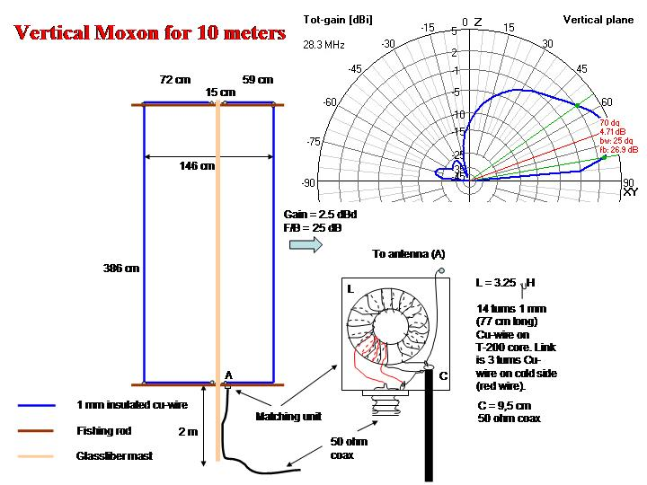

Here you can see the LC circuit inside a plastic box:

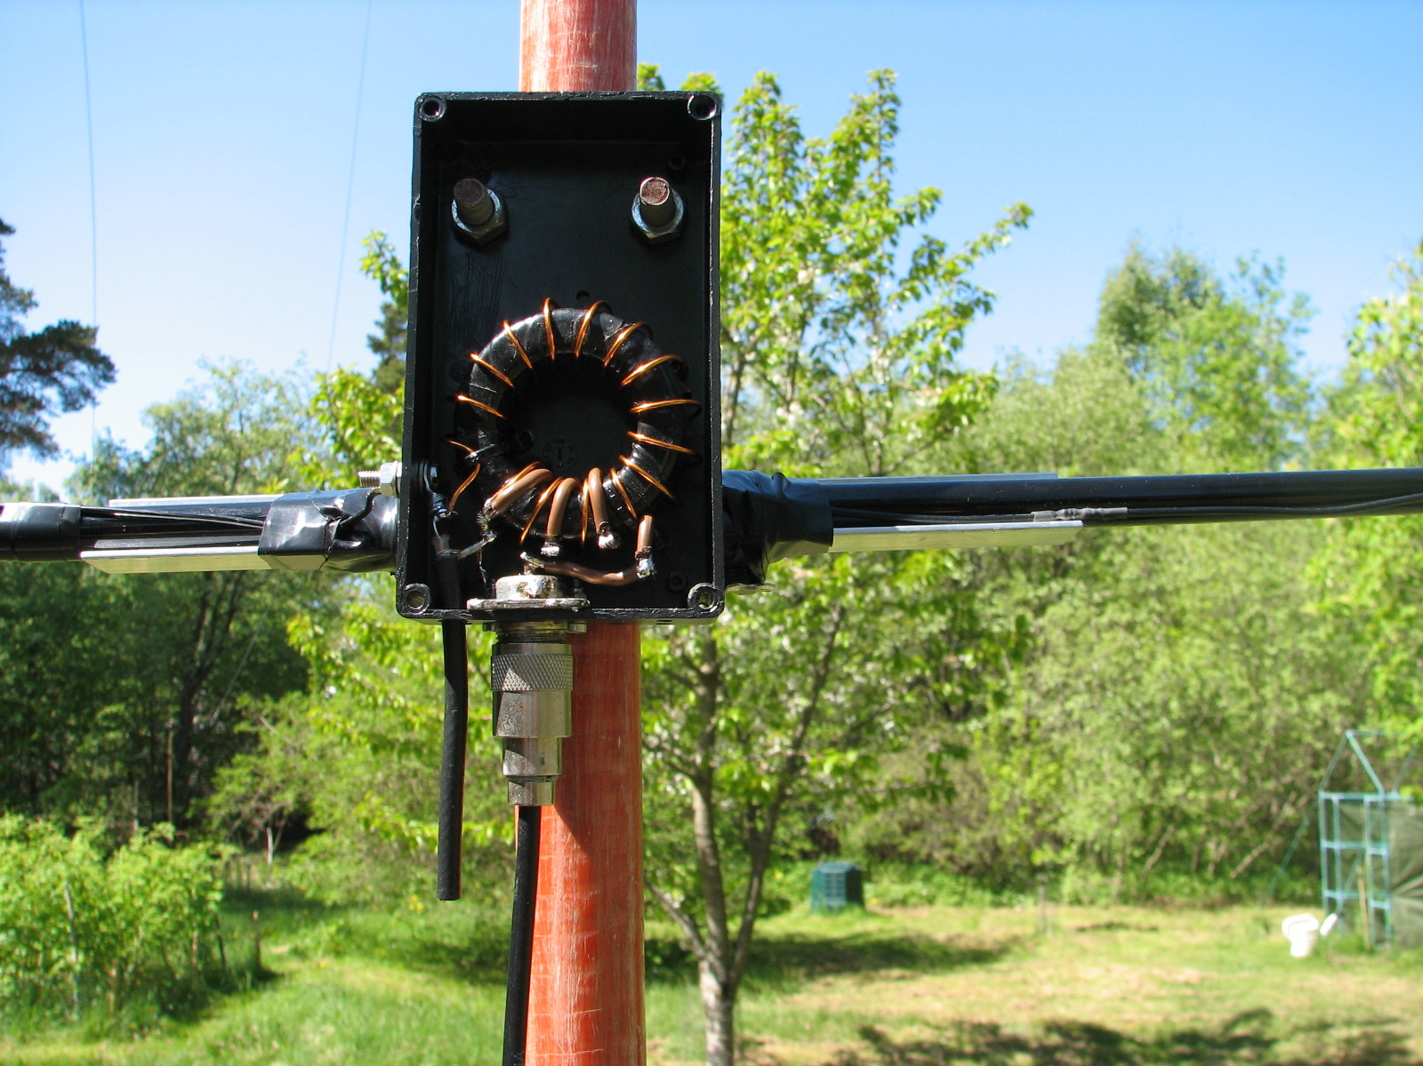

And this is how it looks on the air:

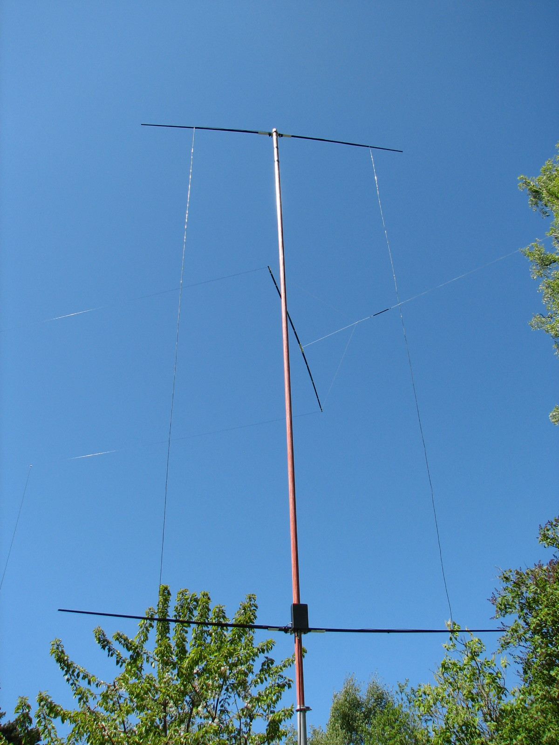

In the background you can see a Moxon antenna for 40 meters.

73 de SM0DTK, Martin
sm0dtk@passagen.se
http://hem.passagen.se/sm0dtk/

